Rutgers Hillel Elections Committee Handbook
Spring 2019

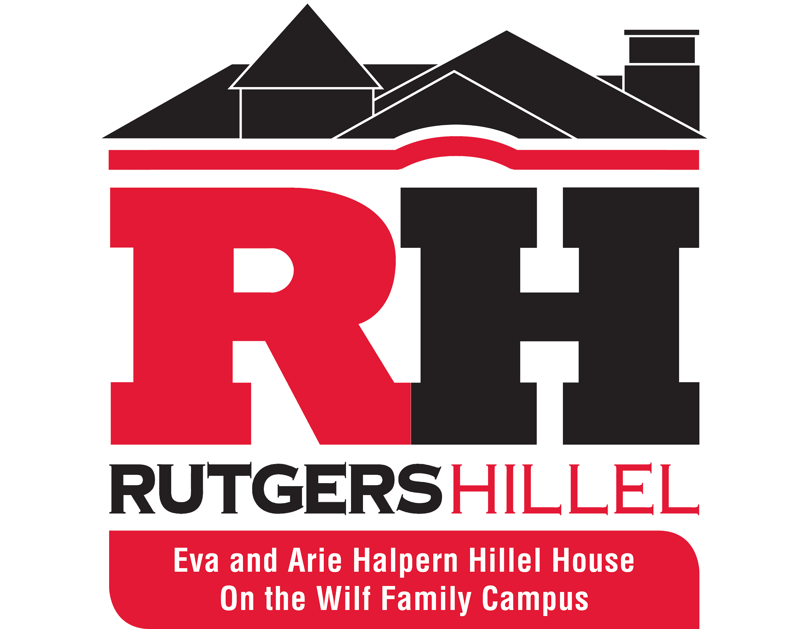

Elections Timeline…………………………………………….....Page 2
Hillel Student Board Member Requirements…...………...…..Page 3
Hillel Student Board Application…………...…….………….…Page 9
Eligibility for the Position of President…………………….......Page 10
Appeals Process………………………………………………...Page 10
Campaigning Rules and Procedures……………...………..…Page 11
Voter Eligibility…………………………………….…..……..…..Page 12

Elections Timeline

Monday, March 4th Prospective Candidates Information Session 1
7:30 – 8:30 pm in Hillel

Tuesday, March 5th Prospective Candidates Information Session 2
8:30 – 9:30 pm in Hillel

Tuesday, March 26th Appeals are due by 12 noon but encouraged to be submitted earlier.

Wednesday, March 27th Applications are due by 12 noon

Wednesday, April 3rd Candidates Forum: All candidates deliver
speeches and answer questions in Hillel beginning at 9:00 pm. Voting goes live
online immediately following the final speech.

Wednesday, April 3rd Voting is open online following the final speech.

Thursday, April 4th Voting is open online until Midnight.

Friday, April 5th The Elections Committee tallies the votes and informs candidates of the results before publishing them in an email sent to the Hillel listserv.

Friday, April 5th Election winners are recognized at Shabbat dinner.

Board Meetings:
Mondays after elections will be transitional meetings at 9:00 pm
Dates: April 8th, April 15th, April 22nd, April 29th, May 6th

Sunday, April 28th Board officially changes over during the End of Year Hillel Banquet

The newly elected board serves for one year.
Requirements of Board Members

Board members are expected to:
- Attend weekly meetings of the Hillel Board. These can either take place in person or online. All meeting dates and times are at the discretion of the President.
- Attend weekly advising meeting with their Rutgers Hillel staff advisor.
- Help promote and execute Shabbat dinner program(s). Board members need to attend half of the Shabbat Dinners each semester.
- Attend and support at least 1 event planned by each other board member per semester.
Candidates who would like to run as a slate of 2 co-chairs for the following positions, are permitted to do so: Social and Holiday Chair, Orthodox Chair, Conservative Chair, and Reform Chair. Co-chairs may not alternate attendance at board meetings/ Shabbat dinner.

Candidates who would like to run as a slate of 2 co-chairs for other positions must follow the appeals process.

All board members must attend student leadership training seminars. These are usually held in May, August and January.

Officer Responsibilities of the Hillel Student Board
11a. President-
The President shall be responsible for informing the members of the Hillel Student Board about Rutgers University regulations and policies and shall be responsible for all student board functions. The President shall be responsible for organizing and running all meetings of the Hillel Student Board. The President shall be responsible for overseeing and advising the Student Board, making sure that each Student Board member carries out their assigned duties in a timely fashion.
The President shall be also responsible for upholding the Hillel Student Board Constitution as Parliamentarian. The President is also responsible for distribution of the Hillel constitution. The President will act as "Speaker of the House" at meetings and consult with the assigned administrative advisor in regards to constitutional issues. The President shall be the official Rutgers University representative of Rutgers Hillel and shall act as the liaison to fellow student organizations, with the support of the Executive Vice President. The President will be responsible for forming coalitions between Hillel and other organizations on campus. The President serves as the liaison between the Hillel Foundation board and the Hillel Student Board as well as between the Hillel staff and the Hillel Student Board. The President oversees all committees to ensure that committee members are fulfilling their duties, that the committee is in communication frequently, and that the committee heads are delegating responsibilities.
The President shall be responsible for attending meetings of the Board of Directors of the Hillel Foundation to inform the Foundation of student activities as well as be informed of the Foundation's activities. The President shall be responsible for meeting with a staff member of Hillel on a regular basis. The President shall consult and coordinate with the Hillel Staff about student use of the Hillel Building. The President shall have a sense of the programming calendar and work in conjunction with the Executive Vice President to ensure that all activities, events, and rooms are planned and used well. The President works with the Board to plan and execute all leadership training sessions as well as pre-semester activities. The President is responsible for creating, maintaining, and managing the Shabbat Dinner greeters and announcement rotations.

The President shall work closely with the Executive Vice President to assess the state of Jewish life at Rutgers and to work on a broad vision for the Jewish community.

11b. Executive Vice President-
The Executive Vice President oversees special projects, such as new initiatives within Hillel. In that role, the Executive Vice President can plan programming directly or assist other students who would like to plan programs. The Executive Vice President should put forward a mechanism, of their choosing, each semester that allows all students, specifically non-board students to send event ideas and request money for their events. The Executive Vice President will be responsible for overseeing these initiatives and events, alongside their staff supervisor. The Executive Vice President is required to plan at least one co-sponsored event per semester for the religious communities as a collective task and shared financial obligations. The Executive Vice President works closely with the President, as they both have executive roles.

The Executive Vice President is also in charge of outreach. Through this role, the Executive Vice President will work closely with the LEAD fellows to ensure that people are being brought into Hillel through a variety of sources. Additionally, the Executive Vice President will be given a budget to take students out for coffee, like LEAD fellows, to continue fostering an outreach initiative.

The Executive Vice President shall work closely with the President to assess the state of Jewish life at Rutgers and to work on a broad vision for the Jewish community.

11c. Treasurer-
The Treasurer processes the Student Board’s budgets and oversees the RUSA budget. The Treasurer is responsible for re-registering Hillel as a Rutgers student organization. The Treasurer is responsible for coordinating a system of allocations of funds for programming. The Treasurer is responsible for issuing a treasury report at meetings of the Student Board. The Treasurer is responsible for creating and defending the yearly budget.

The Treasurer will be responsible for presenting, auditing, and re-allocating funds as deemed necessary once a month, during a board meeting.

11d. Vice President of Communication -
The Vice President of Communication is responsible for keeping minutes at meetings and fostering PR and various “engagement” tools for Hillel programming. The Vice President of Communication is responsible for advertising for Hillel through, for example, the weekly email, Hillel happenings, and other tools deemed necessary. The Vice President of Communication is also responsible for taking inventory of student supplies and purchasing overhead supplies as necessary.

The Vice President of Communication is responsible for creating the Facebook event for Weekly Shabbat Dinner in a timely fashion. The Vice President of Communication is also responsible for making flyers for events. While flyers are not mandatory for each event, the student board members will have the option to ask the Vice President of Communication for assistance in creating flyers for events. The turnaround time and deadlines for flyers will be determined by the Vice President of Communication.

11e. Vice President of Pluralism and Education -
The Vice President of Pluralism and Education shall be responsible for coordinating programs that will enhance the community’s Jewish educational experience. The Vice President of Pluralism and Education shall work to foster a pluralistic learning environment, in which all the varied needs of Hillel’s membership can be met. The Vice President of Pluralism and Education is responsible for creating large and small-scale programs for various events. The Vice President of Pluralism and Education is responsible for maintaining interdenominational educational programing, through interactive activities and text study sessions.

The Vice President of Pluralism and Education should work to create Holocaust Programming throughout the year, including, but not limited to, Kristallnacht and Yom Hashoah. The Vice President of Pluralism and Education is also responsible for the creation and collaboration of Interfaith programming events, such as Dialogues, Trialogoues, or Interfaith Shabbat Dinners.

11f. Social and Holiday Programming Chair -
The Social and Holiday Programming Chair shall be responsible for overseeing the running of social programming at Rutgers Hillel. The Social and Holiday Programming Chair shall be responsible for a minimum of three social programs per semester, such as, but not limited to, Midknight Breakfast, Kosher Fat Sandwich Night, Ice Skating, etc.

The Social and Holiday Programming Chair shall also be responsible for overseeing various holiday programming at Rutgers Hillel to promote interaction among all Jewish students at Rutgers. The Social and Holiday Programming Chair shall be responsible for coordinating various large and small-scale holiday programs such as Sukkot Event, Hanukkah Ball, Tu B’Shvat, and a Purim celebration, among other events.

The Social and Holiday Chair Programming is also responsible for organizing Passover meals during the intermediate days of the holiday.

11g. Shabbat and Social Action Chair -
The Shabbat and Social Action Chair is responsible for organizing Shabbat activities. These include, but are not limited to, organizing Oneg parties throughout the semester, community-wide lunches, Challah Baking, etc. The Shabbat and Social Action Chair is responsible for organizing at least one Shabbat activity per month.

The Shabbat and Social Action chair shall also be responsible for fostering community service programs in which Rutgers University students can volunteer their time. The Shabbat and Social Action Chair shall lead the Hillel community-based social action programs. The Shabbat and Social Action Chair shall be the liaison to other social action organizations on campus. The Shabbat and Social Action Chair shall be responsible for coordinating various large and small-scale programs for various events, such as Good Deeds Day, Chicken Soup for Stein Hospice (as needed), Mishloach Manot packaging, etc. The Shabbat and Social Action Chair shall also be responsible for coordinating at least 1 drive (food, clothes, blood drive, etc.) per semester.

The Shabbat and Social Action Chair should be in contact with the Rutgers Tzedek League, which should serve as the basis for a committee under this position.

11h. Israel Chair-
The Israel Chair shall be responsible for overseeing programming, in accordance with the Hillel International Israel policy. It states: “Hillel is committed to Israel’s right to exist and flourish as a Jewish and Democratic state within secure and recognized boundaries. Hillel welcomes, partners with, and aids the efforts of organizations, groups, and speakers from diverse perspectives in support of Israel as a Jewish and democratic state. Hillel will not partner with, house, or host organizations, groups, or speakers that as a matter of policy or practice:
- Deny the right of Israel to exist as a Jewish and democratic state with secure and recognized borders;
- Delegitimize, demonize, or apply a double standard to Israel;
- Support boycott of, divestment from, or sanctions against the State of Israel;
- Exhibit a pattern of disruptive behavior towards campus events or guest speakers or foster an atmosphere of incivility.”
The Israel Chair is responsible to oversee programs that can involve, but are not limited to, aspects of Israeli culture, education and politics. The Israel Chair is responsible for building pro-Israel coalitions in the greater Rutgers community and for other Israel needs that arise throughout the semester.
11i. Reform Community Chair(s) -
The Reform Community Chair(s) will be responsible for religious services geared towards their community. The Reform Community Chair(s) can also plan social and educational events, as necessary, to strengthen their community. The Reform Community Chair(s) shall be the liaison between their religious community and the rest of the Hillel Student Board.

11j. Conservative Community Chairs(s) -
The Conservative Community Chair(s) will be responsible for religious services geared towards their community. The Conservative Community Chair(s)can also plan social and educational events, as necessary, to strengthen their community. The Conservative Community Chair(s) shall be the liaison between their religious community and the rest of the Hillel Student Board.

11k. Orthodox Community Chair(s) -
The Orthodox Community Chair(s) will be responsible for religious services geared towards their community. The Orthodox Community Chair(s) can also plan social and educational events, as necessary, to strengthen their community. The Orthodox Community Chair(s) shall be the liaison between their religious community and the rest of the Hillel Student Board. The Orthodox Community Chair(s) must have served previously on the Orthodox community’s board. If the Orthodox Community Chair(s) has not previously served on the Orthodox community’s board, an appeal must be made to the Orthodox community board before the candidate applies for the position.

Application to apply for Hillel Student Board

This applications is available for download on rutgershillel.org (Under “About Us” - “Student Leadership” - “Student Board,” at the bottom of the page)

Email only this page of the document along with a copy of your campaign poster by 12 noon on Wednesday, March 27th to elections@rutgershillel.org with a headshot photo (in.JPEG format) attached.

Save this document as LASTNAME_FIRSTNAME and in .doc or .docx format.

Name:
Graduation Year:
Major/s:
Email Address:
Alternate Email Address (optional):
Phone Number:
Desired Position:

Please complete a letter of intent no longer than 500 words, outlining your experience, qualifications and why you want to run for this position. Also address any new ideas you have for this position, as well as your goals for Hillel as an organization. Please be aware that this letter of intent will be on the online ballot with your picture. This is not necessarily your speech. Type it here:

Please do not forget to include a headshot of yourself (in.JPEG format)

Eligibility for the Position of President

To be eligible for elections as President a member has had to have completed a term of no less than 3 months on the Hillel Student Board. Completing a term is defined as serving the full length of the elected term, without being impeached or resigning.

a. A student who would like to run for President and has not previously served on the Hillel Student Board may gain approval from the elections committee to run for President. All appeals must be submitted to elections@rutgershillel.org by Tuesday, March 26th, 2019 by 12 noon.

b. In the event that no Board member is running for the office of the President, the position will be open to any Rutgers Hillel member.

This means that if you would like to run for the office of President and you have not completed a term on board, you must submit an appeal to the Elections Committee at elections@rutgershillel.org by 12 noon on Tuesday, March 26h.

Co-Chair Appeal Process

In the event that 2 or more people would like to run for a position together, that is not stated to allow co-chairs, they may submit an appeal to the elections committee by Tuesday, March 26th at 12 noon. Reasons to appeal are: studying abroad, early graduation, internship/co-op, and others. All reasons are subject to the discretion of the elections committee.

This means if you would like to run for a co-chair position for the following positions (VP of Pluralism and Education, Shabbat and Social Action Chair, and Israel Chair), you must submit an appeal to the Elections Committee at elections@rutgershillel.org by 12 noon on Tuesday, March 26th.

Campaigning Rules & Procedures

I. A candidate may campaign for him/herself and/or co-­chair, but may not mention any other candidate running for any position in the context of elections both in person and online (i.e. Facebook, Twitter, etc.)

II. A candidate may encourage individuals to vote for him/herself and may solicit votes from a formal group online (Facebook groups, Facebook pages, email listservs, organizational social media accounts, etc.) or in formal group meetings or events. A candidate may not create a Facebook group or page about their candidacy. A candidate may not solicit an official endorsement from an organization. A candidate MAY NOT “bash” another candidate (whether they are running against them or not) in any form. Any postings that are deemed inappropriate or demeaning will be dealt with accordingly.

III. Each Candidate is allowed up to 10 flyers, no larger than 8.5” x 11” to be hung in the Hillel building. Flyers may only be hung in the Hillel building in designated sections. They must to be emailed to the elections committee to be approved and printed, they can be picked up in the Hillel office. Before posting/hanging any flyers, the flyer and location must be approved by a Hillel staff member. Any flyer that is deemed inappropriate will be dealt with accordingly.

IV. “Candidate” is defined as anyone who submits a letter of intent to the elections committee and is running for any position in the Hillel student board elections 2019.

V. Staff members and Elections Committee members are not allowed to endorse any candidate. Candidates may not claim to have the endorsements of staff or Election Committee members.

VI. Any infraction not listed here deemed flagrant by the Election Committee can be seen as a possible violation.

VII. The following are the consequences of violating any of the above rules:
(1) Upon a first violation, the offending candidate will appear before the elections committee to state their case. The elections committee will deliberate to determine the severity of the violation and its consequences for the elections, and will then vote on whether or not to declare the candidate in question ineligible to run in the election. A 2/3 vote is need to invalidate the candidate.

(2) After a second violation, the offending candidate will again appear before the elections committee to state his or her case. The elections committee will deliberate to determine the severity of the violation and consequences for the elections, and will then vote on whether or not to declare the candidate in question ineligible to run in the election. A majority vote is needed to invalidate the candidate.

(3) After a third violation, the offending candidate will automatically be declared ineligible to run in the election.

(4) If a candidate commits multiple offenses prior to meeting with the election committee, it is up to the discretion of the committee to treat this as either a first, second, or third offense.

If you feel that a candidate has violated any of the above rules, please send an email to elections@rutgershillel.org. Any accusations of violation will be dealt with anonymously.

Voter Eligibility

According to the Hillel Constitution a Voter is eligible to vote in the Hillel Student Board Elections provided that they are an undergraduate student at Rutgers University and are “on the membership list by noon of the day after elections go live.”

The membership list is defined as follows: A student who signed in at any Rutgers Hillel event, or at the Hillel building during the time of elections, is also on the membership list.

All eligible voters may only vote online one time.

